**Operating System (CS604)**

**Assignment # 01**

**Spring 2022**

**Solution:**

**Question 1:**

* Open the Terminal window and show the listing of all the files and folder in the current working directory by using the ls command.
* Create the directory with your own name along with your VUID.

You are required to send the screenshot of above two activities.

Following is the sample Screen shot.

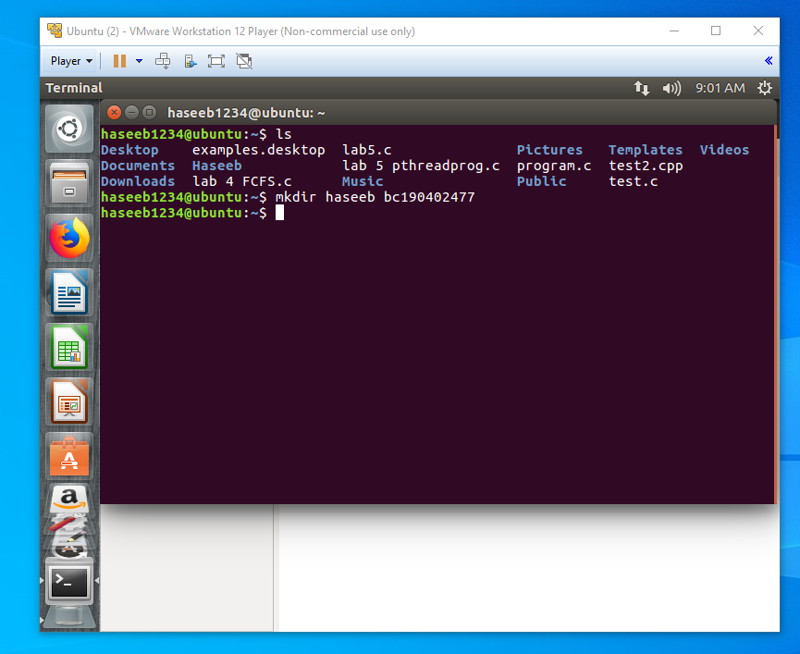

**Question 2:**

Write a C program with parent process that create the child process through fork () system call. Child and parent process perform the following functionalities.

* Child process should print your own VUID, VU CampusID.
* Parent process should print the Campus name and used the wait () system call so that child can perform the required functionality.

Following should be the flow of your program.

* Firstly, compile your C program using gcc command.
* Run the C program

You are required to send the screenshot of above activities along with the C Code in Same Word File.

**C Code:**

#include <sys/types.h>

#include <sys/wait.h>

#include <stdio.h>

#include <stdlib.h>

#include <errno.h>

#include <unistd.h>

void main()

{

int pid, status;

pid=fork();

if (pid= = -1)

{

printf("fork failed \n");

exit(1);

}

if(pid==0)

{

printf("in child process \n\n");

printf("VUID Bc190402477 \n");

printf("CampusID Pfjn01 \n\n");

exit(0);

}

else

{

wait(&status);

printf("in parent process \n\n");

printf("Virtual University Fateh jang campus \n");

exit(0);

}

}

**Following is the screenshot:**

